FINAL PROJECT REPORT

DEPARTMENT OF ELECTRICAL ENGINEERING

IIT KANPUR

NAME: DHRUV SARASWAT

Institute: NIT Rourkela (B.Tech, EE)

PF. NO: C20408

PROJECT NO: IUSSTF/EE/2017282D

PROJECT TITLE: Ui- Assist:IIT Kanpur Pilot 2B

Principal Investigator: Prof. Ankush Sharma

Gateway and STM32 (blue pill and black pill) controlled board

Altium Tutorial: https://youtu.be/PqFtSpAXB9Q

This project based on designing of a printed circuit board containing STM32 blue pill, Lora gateway, DB9 male connector, Hi-Link(AC-DC convertor), UFL antenna to transmit signals and IC's like MAX485 and MAX232 with their connections with several capacitors, resistors , STM32 (blue pill) and various other components on the board. The dimension of the PCB is 7.5mm x 4.3mm. this PCB helps in collecting the data from a meter like Voltage, Current, Power (KWh) and frequency and send it in rc packets form to the receiver consisting of Raspberry Pi and LoRaWAN concentrator which are connected through a gateway. The PCB model of that gateway is also designed by me.

Gateway to connect Raspberry PI and LoRaWAN concentrator

Project name: Pi Hat

PCB document-2d

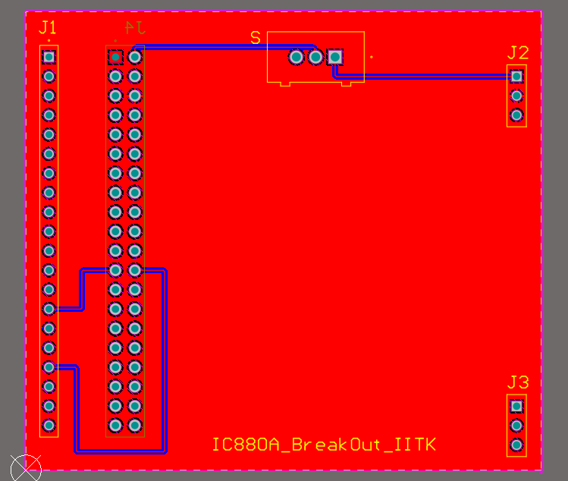

3d front side:

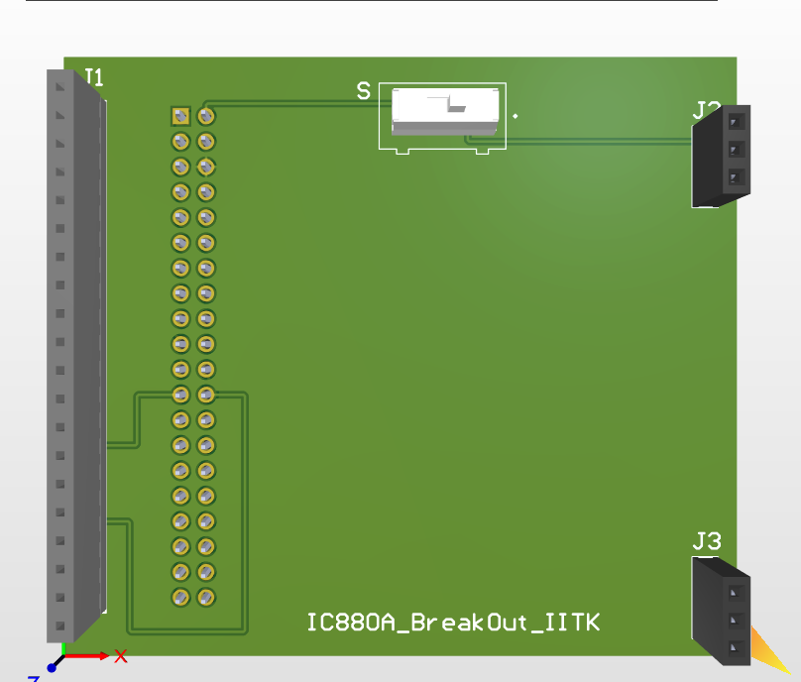

Schematic:

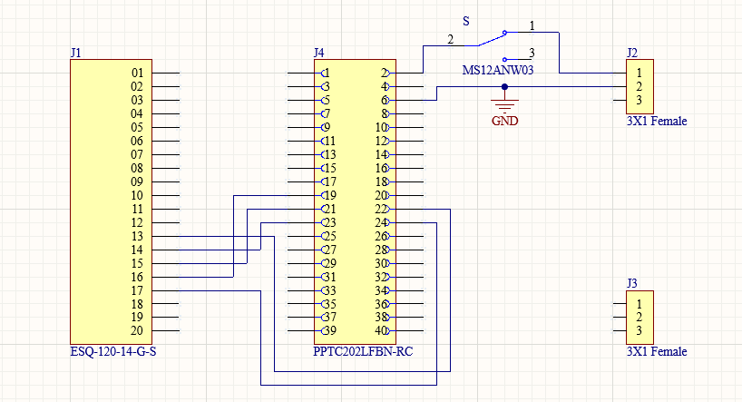

3D backside

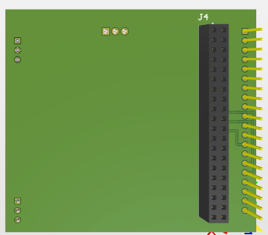

PCB Lib

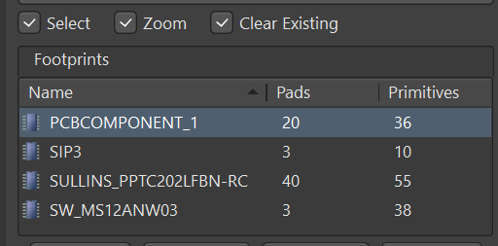

SCH Lib

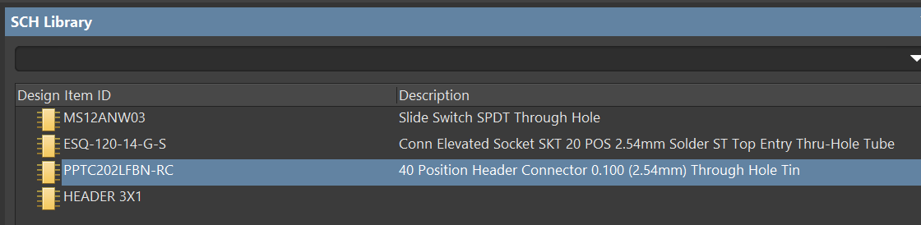

Bottom layer

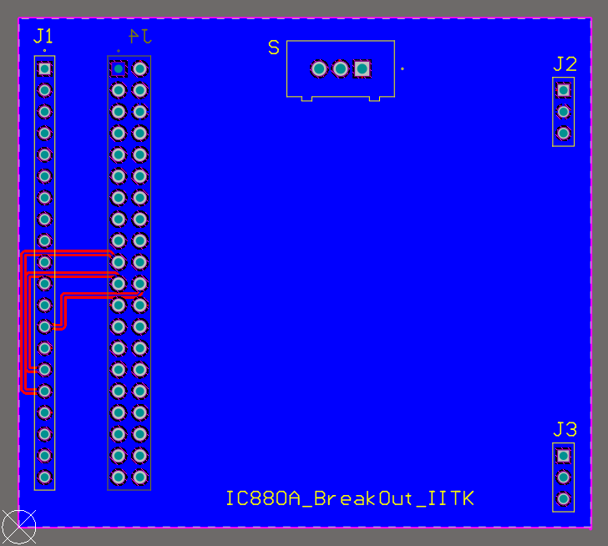 Distance between 2 pins of all 4 headers and switch = 2.54mm

Standoff height for 20x1 male header= 100 mil

Standoff height for 20x2 male header and 3x1 header= 00 mil

Standoff height for switch= 1.346mm

**Links**

3x1 header

[2-644861-3 TE Connectivity AMP Connectors | Connectors, Interconnects | DigiKey](https://www.digikey.in/en/products/detail/te-connectivity-amp-connectors/2-644861-3/698414)

10x1 header

[0705430114 Molex | Connectors, Interconnects | DigiKey](https://www.digikey.in/en/products/detail/molex/0705430114/1643363)

20x1 header

[PPTC202LFBN-RC footprint & symbol by Sullins Connector Solutions | SnapEDA](https://www.snapeda.com/parts/PPTC202LFBN-RC/Sullins%20Connector/view-part/?ref=digikey)

Switch

[MS12ANW03 NKK Switches | Switches | DigiKey](https://www.digikey.in/en/products/detail/nkk-switches/MS12ANW03/1051368)

**How to start project:**

* File> new> project> name it.
* Right click on project> add new to project> add pcb, schematic, pcblib and sch lib.
* After adding all 4 of them save it.

**How to add footprint and 3d body**

* Search the respective product in digikey and filter the ead/cad file.
* Download the cad model and 3d body from link of snapeda or ultra librarian and extract the zip file.
* Open Altium and drag files from download directly to Altium.
* Then go to pcblib>place>3d body>select relevant step file>okay.
* View> 3d layout mode / press 3 > check the orientation of 3d body and place accordingly. Use enter to rotate it.
* Else right click > properties>change rotation angle and standoff height. Fit the 3d body on footprint correctly.
* Press 2 to go to 2d view and save.
* Repeat the same process for adding different components.
* Save the pcblib and schlib after adding all the components.
* For models downloaded from **ultra librarian** to add them
* File>run script>browse> from file> select extracted file> okay
* File>select text file> start import.

**How to add components in schematic and do the connections:**

* Go to schematic > panels > suitable schlib> components> drag all the components one by one.
* 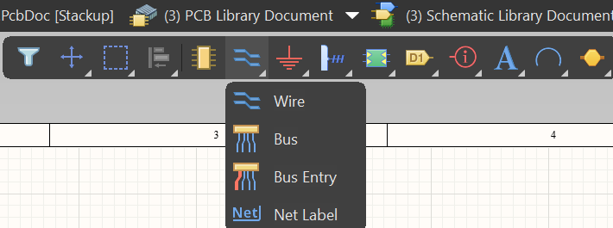
* For doing connections either use wire or net label
* Put net label on one end and rename accordingly
* Use same net label on other end where u need to connect.

**How to place the components from schematic to pcb:**

* Schematic> design> update pcb doc> validate changes> execute change.
* Place the components on the board so that they occupy least space

**Resize the pcb board:**

* Select board out, place the origin on bottom left corner.
* Edit> origin> set> place on corner.
* 
* Place line> press J then L> select the location and define the board.
* Use J then L 5 times. To return to origin again
* Click on one of the line > press tab to select all lines> design > board shape> define board shape.
* 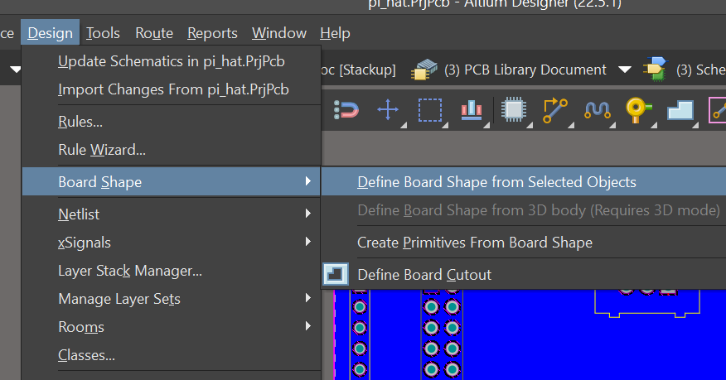

**How to do routing between components:**

* 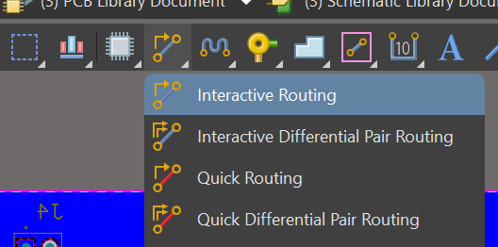
* Interactive routing> select the terminals and join.
* If required do the routing using Via.
* 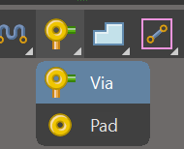
* Place via > on one/both terminals as needed and do the routing on back layer
* After placement and routing of components>tools> design rule check.
* 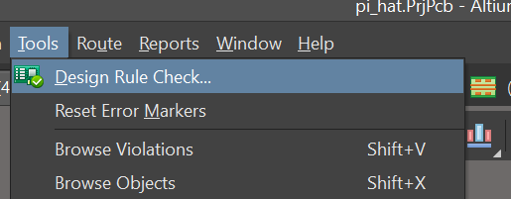
* Then output job file
* Right click on project>add new to project> output job file
* 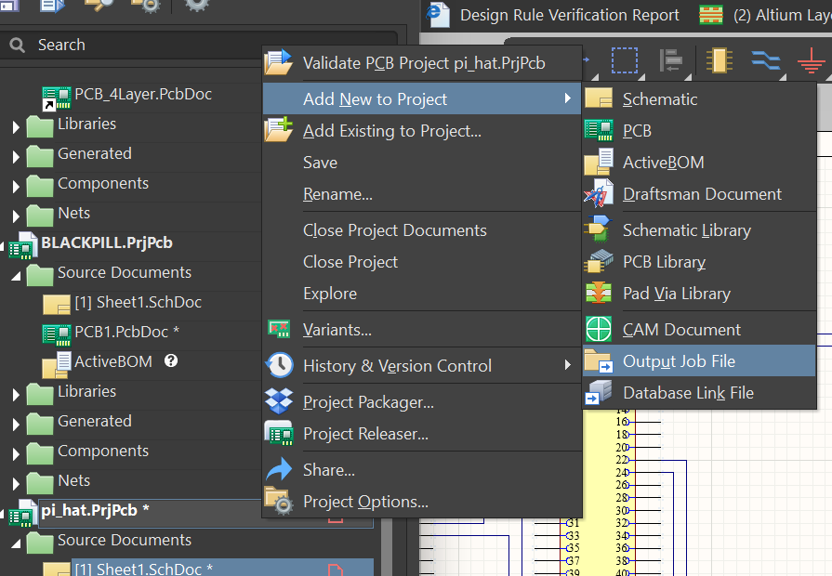
* Fabrication output>gerber file > pcb doc.
* Similarly obtain nc drill file
* 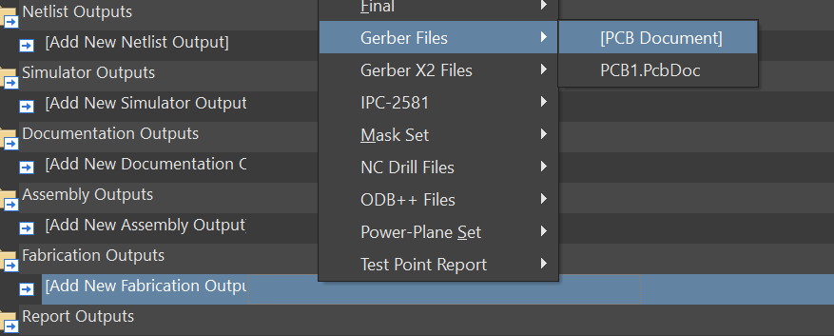

**STM32F103 (BLUE PILL) controlled PCB**

2D Top Layer

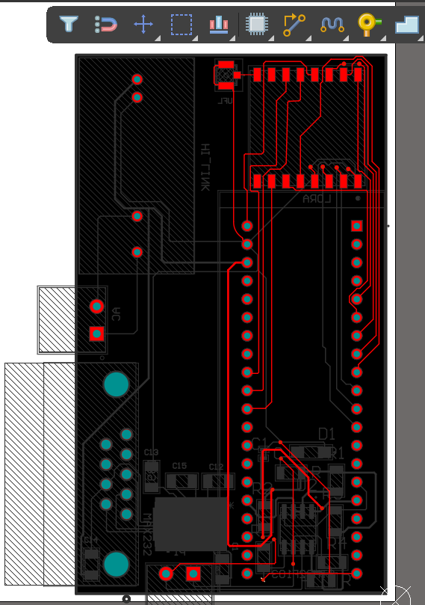

2d Bottom Layer

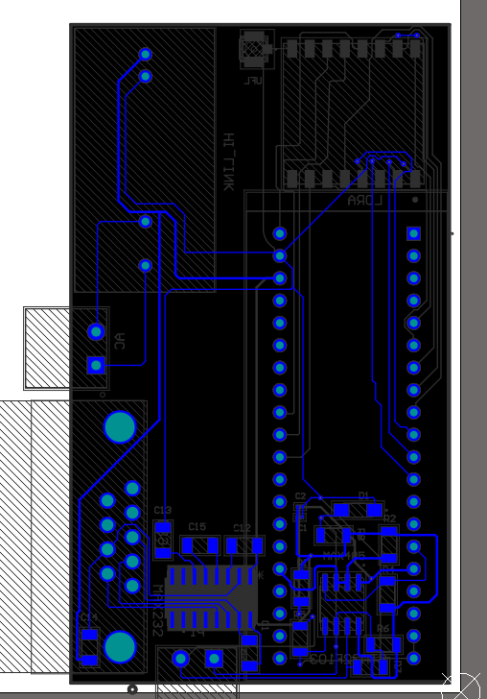

3D Top Layer

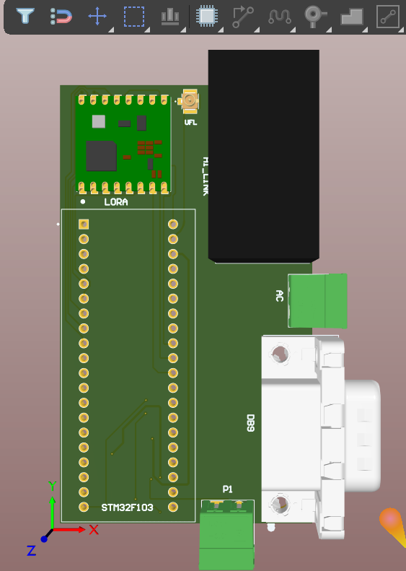

3D Bottom Layer

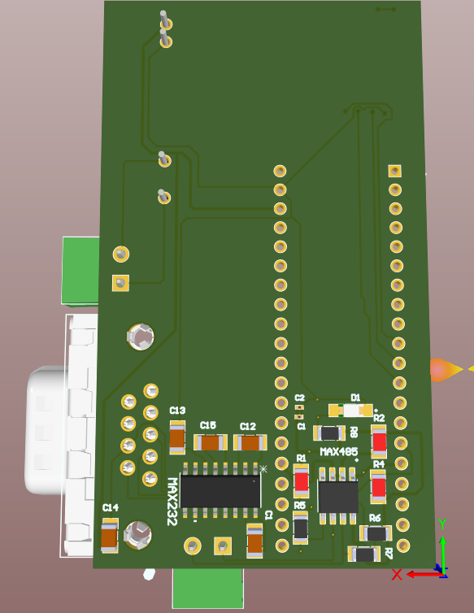

Schematic

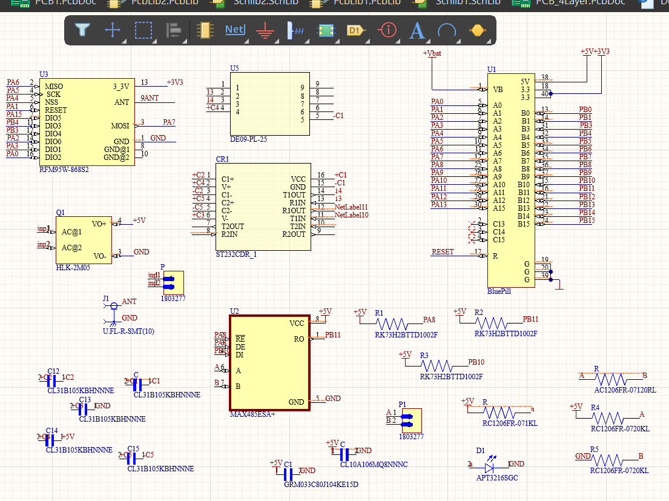

PCB Lib:

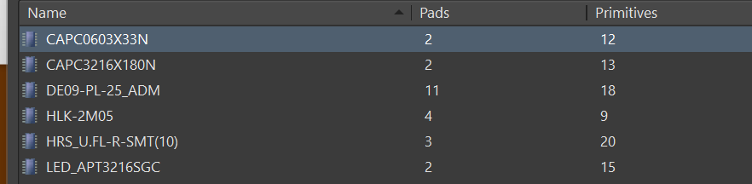

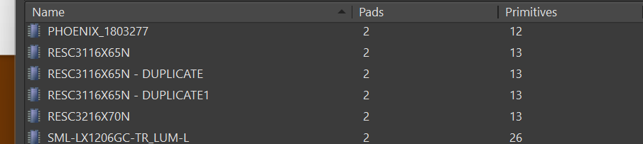

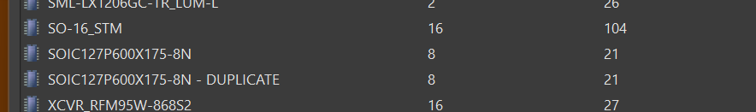

SCH Lib:

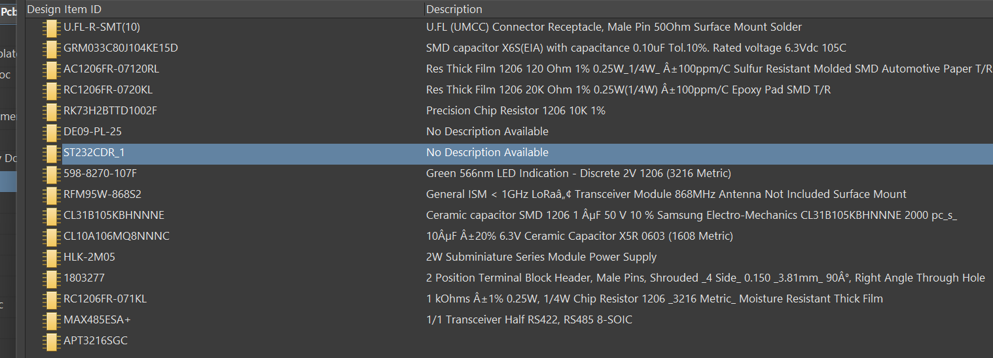

Links:

MAX485

[MAX485ESA+ footprint & symbol by Analog Devices | SnapEDA](https://www.snapeda.com/parts/MAX485ESA+/Maxim%20Integrated/view-part/?ref=digikey)

10K RESISTOR

[RK73H2BTTD1002F KOA Speer Electronics, Inc. | Resistors | DigiKey](https://www.digikey.in/en/products/detail/koa-speer-electronics-inc/RK73H2BTTD1002F/10235985)

0.1uF capacitor

[GRM033C80J104KE15D Murata Electronics | Capacitors | DigiKey](https://www.digikey.in/en/products/detail/murata-electronics/GRM033C80J104KE15D/5027475)

10uF capacitor

[CL10A106MQ8NNNC Samsung Electro-Mechanics | Capacitors | DigiKey](https://www.digikey.in/en/products/detail/samsung-electro-mechanics/CL10A106MQ8NNNC/3886777)

20k resistor

[RC1206FR-0720KL footprint & symbol by Yageo | SnapEDA](https://www.snapeda.com/parts/RC1206FR-0720KL/Yageo/view-part/?ref=digikey)

120ohm resistor

[AC1206FR-07120RL YAGEO | Resistors | DigiKey](https://www.digikey.in/en/products/detail/yageo/AC1206FR-07120RL/5897228)

1k resistor

[RC1206FR-071KL YAGEO | Resistors | DigiKey](https://www.digikey.in/en/products/detail/yageo/RC1206FR-071KL/728387)

led

[5988270107F Dialight | Optoelectronics | DigiKey](https://www.digikey.in/en/products/detail/dialight/5988270107F/1291287)

UFL

[U.FL-R-SMT(01) Hirose Electric Co Ltd | Connectors, Interconnects | DigiKey](https://www.digikey.in/en/products/detail/hirose-electric-co-ltd/U-FL-R-SMT-01/513010)

DE09

[DE09-PL-25 Adam Tech | Connectors, Interconnects | DigiKey](https://www.digikey.in/en/products/detail/adam-tech/de09-pl-25/9832369)

RFM 95

[RFM95W-868S2 RF Solutions | RF and Wireless | DigiKey](https://www.digikey.in/en/products/detail/rf-solutions/rfm95w-868s2/5051755)

1Uf capacitor

[CL31B105KBHNNNF Samsung Electro-Mechanics | Capacitors | DigiKey](https://www.digikey.in/en/products/detail/samsung-electro-mechanics/cl31b105kbhnnnf/3894672)

HI LINK

[Buy HLK 2M05 5V 2W AC DC SMPS Power Module | Robu.in](https://robu.in/product/hlk-2m05-5v-2w-ac-dc-switch-power-supply-module/)

STM 232

[ST232CDR STMicroelectronics | Integrated Circuits (ICs) | DigiKey](https://www.digikey.in/en/products/detail/stmicroelectronics/ST232CDR/1039227)

PHOENIX CONTACT

[1803277 Phoenix Contact | Connectors, Interconnects | DigiKey](https://www.digikey.in/en/products/detail/phoenix-contact/1803277/260574)